**Web Programming**

**(LAB Session-1)**

**1.Write a sample HTML code to display few lines of static text using below tags**

**A. At least two header size (from <h1>to <h6>)**

**B. paragraph tag(<p>)**

**C. bold, italic and underline (<b>,<i>,<u>)**

**D. big and small(<big>, <small>)**

**Html Code:**

**<!DOCTYPE html>**

**<html>**

**<head>**

**<title>THIS IS MY TITLE</title>**

**</head>**

**<body>**

**<h1 > header1 </h1>**

**<h2 > header 2</h2>**

**<p>**

**Asynchronous code is a very important part of JavaScript. We need to write lots of asynchronous code since JavaScript is a single-threaded language. If we run everything line by line, then code that takes longer to run will hold up the program, causing it to freeze.**

**</p>**

**<b><i><u> assignment 1</u></i></b>**

**<br>**

**<big>web programing</big>**

**<br/>**

**<small>web programing </small>**

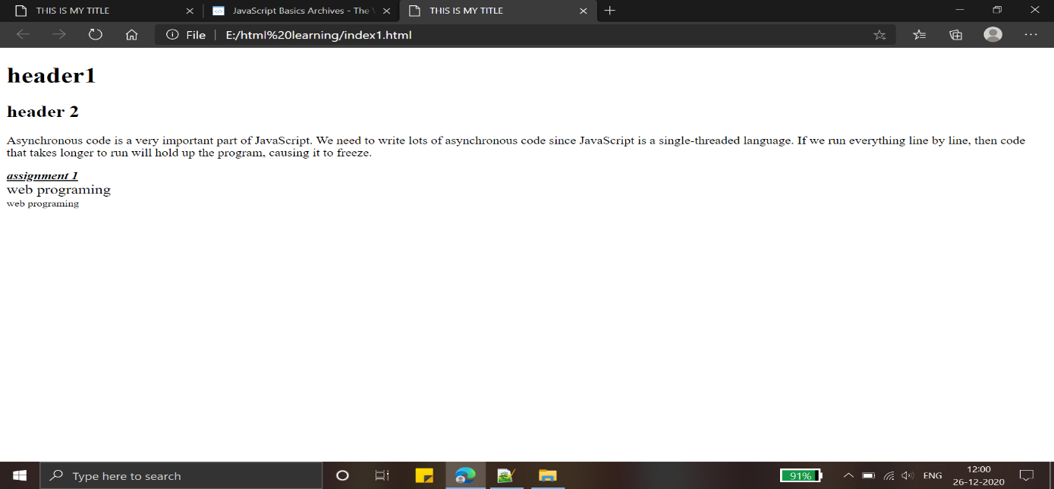

**2.Show usage of any two attributes with each below tags using some static text.**

**a.<body>**

**b.<h1>**

**c.<p>**

**d.<font>**

**code:**

**<!DOCTYPE html>**

**<html>**

**<head>**

**<title>This is my title</title>**

**<body text = "black"**

**Bgcolor=”green”>**

**<font size="4" face="times new roman">**

**<h1 style = "text-align:center" title = "header 1"> web programing</h1>**

**<p style = "text-align:justify" title = "java script" >**

**Asynchronous code is a very important part of JavaScript. We need to write lots of asynchronous code since JavaScript is a single-threaded language. If we run everything line by line, then code that takes longer to run will hold up the program, causing it to freeze.**

**</font>**

**</p>**

**</body>**

**</head>**

**</html>**

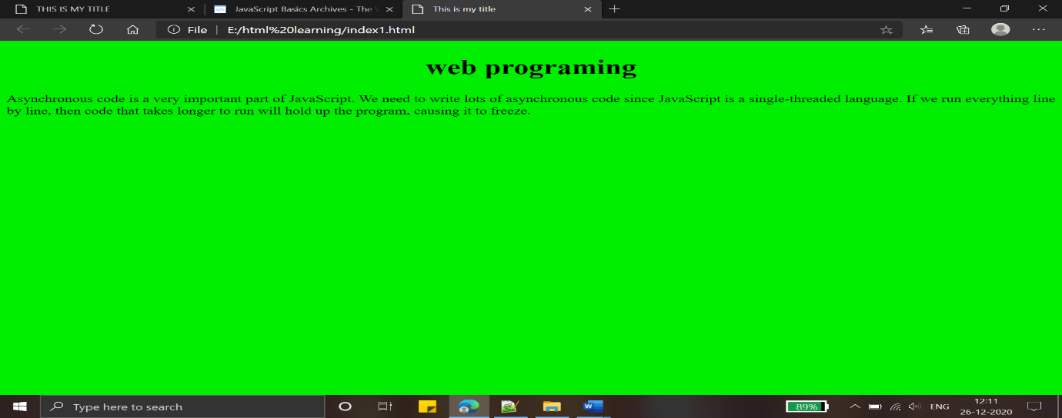

**3.Show usage of image tag (<img>)and anchor tag (<a>) with any two attributes.**

**Code:**

<!DOCTYPE html>

<html>

<head>

<title>assignment 1</title>

<body color="black">

<a href="https://www.geeksforgeeks.org/machine-learning

" target="_blank">next page

<img src= "https://thumbs.dreamstime.com/b/machine-learning-algorithm-concept-related-subject-such-as-decision-tree-artificial-neural-network-deep-sparse-74273951.jpg"/>

width="1200" height="600" alt="there is an erorr to image load" >

</a>

</body>

</head>

</html>

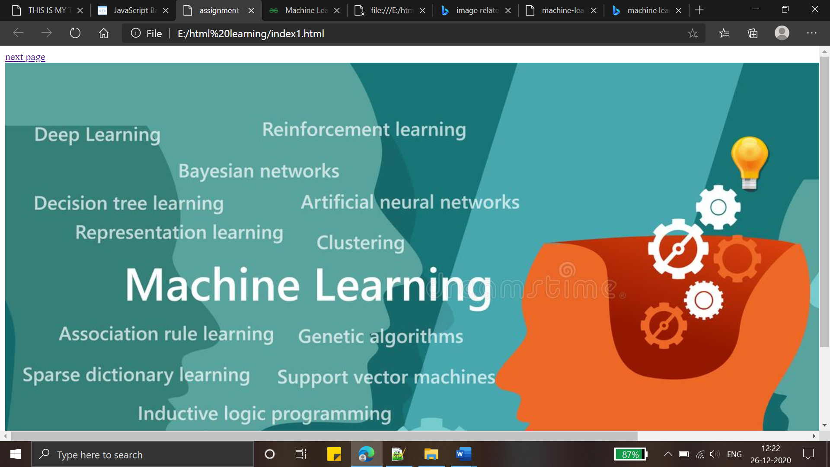

4.Display usage of marquee tag (<marquee>)with attributes like bgcolor, loop and direction(with value up and left).

Code:

<!DOCTYPE html>

<html>

<head>

<title>assignment 1</title>

</head>

<body color="black">

<!--direction no apo to default direction left le and loop no apo to default loop infinite le-->

<marquee bgcolor="blue">web programing</marquee>

<marquee direction="up">web programing</marquee>

<marquee direction="left">web programing</marquee>

<br></br>

<marquee loop="5">web programing</marquee>

</body>

</html>

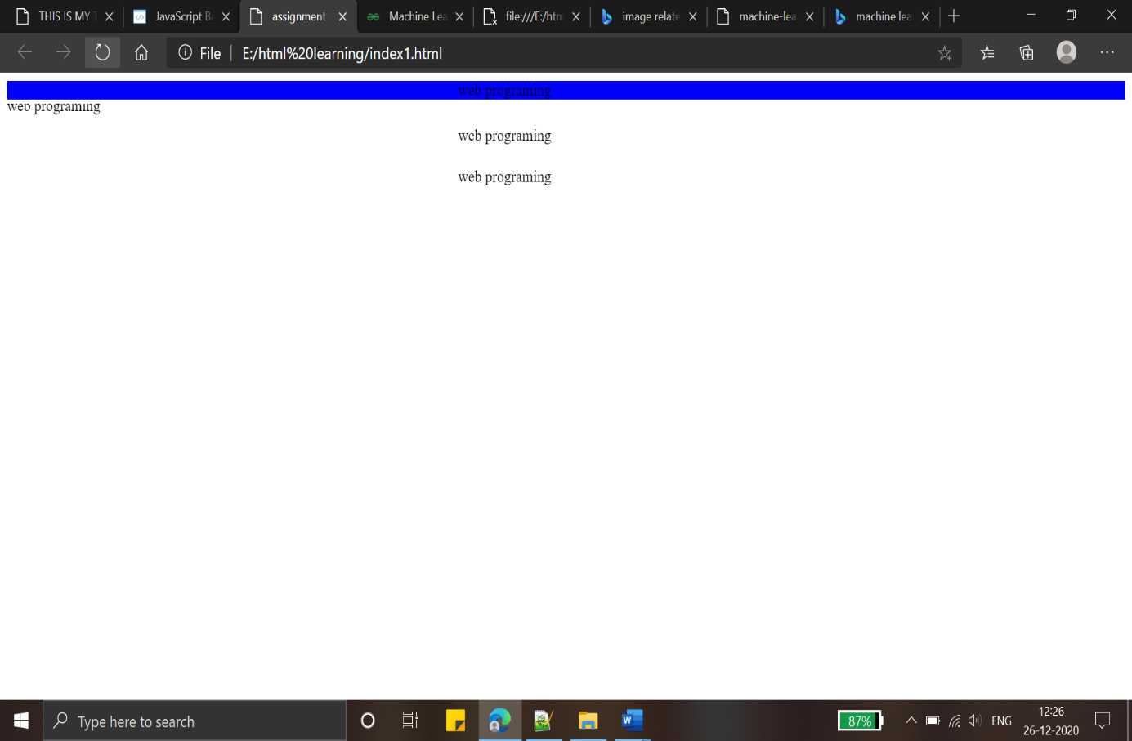

5. Create a static table in html page using (<table>)with attributes like align, bgcolor, height, width and border.

**code:**

**<!DOCTYPE html>**

**<html>**

**<head>**

**<title>assignment 1</title>**

**</head>**

**<body color="black">**

**<style>**

**table,th,td{**

**border:1px solid black;**

**}**

**</style>**

**<table style="float:left" height="200" width="200" align="center" bgcolor="#affff">**

**<caption>CE SEM 6 SUBJECT LIST</caption>**

**<tr>**

**<th> subject</th>**

**<th>prof.</th>**

**</tr>**

**<tr>**

**<td align="center">Wp</td>**

**<td align="center">chinmay sir</td>**

**</tr>**

**<tr>**

**<td align="center">Ajp</td>**

**<td align="center">vishal sir</td>**

**</tr>**

**<tr>**

**<td align="center">Toc</td>**

**<td align="center">urvshi ma'am</td>**

**</tr>**

**<tr>**

**<td align="center">Mpi</td>**

**<td align="center">hardi ma'am</td>**

**</tr>**

**<tr>**

**<td align="center">Iot</td>**

**<td align="center">vishal sir</td>**

**</tr>**

**<tr>**

**<td align="center">Ipdc</td>**

**<td align="center">hardi ma'am</td>**

**</tr>**

**<tr>**

**<td align="center">DE</td>**

**<td align="center">kirit sir</td>**

**</tr>**

**</table>**

**</body>**

**</html>**

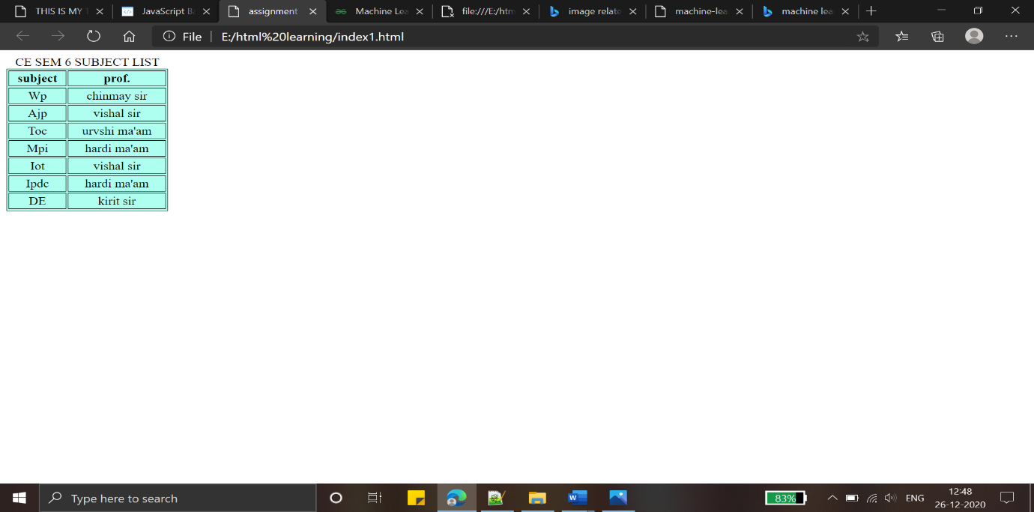

**6.Create an HTML page with static ordered and unordered list of 5 items each**

**<!DOCTYPE html>**

**<html>**

**<head>**

**<title>assignment 1</title>**

**</head>**

**<body color="black">**

**<p><b>list of fruit</b></p>**

**<ol type = "i">**

**<li> mango</li>**

**<li> apple</li>**

**<li> banana</li>**

**<li> cheri</li>**

**</ol>**

**<p><b>list of strongest country in the world</b></p>**

**<ol type = "a">**

**<li> india</li>**

**<li> america</li>**

**<li> china</li>**

**<li> rusia</li>**

**</ol>**

**<p><b>list of world's organization</b></p>**

**<ul>**

**<li> brics</li>**

**<li> g7</li>**

**<li> who</li>**

**<li> un</li>**

**</ul>**

**</body>**

**</html>**

